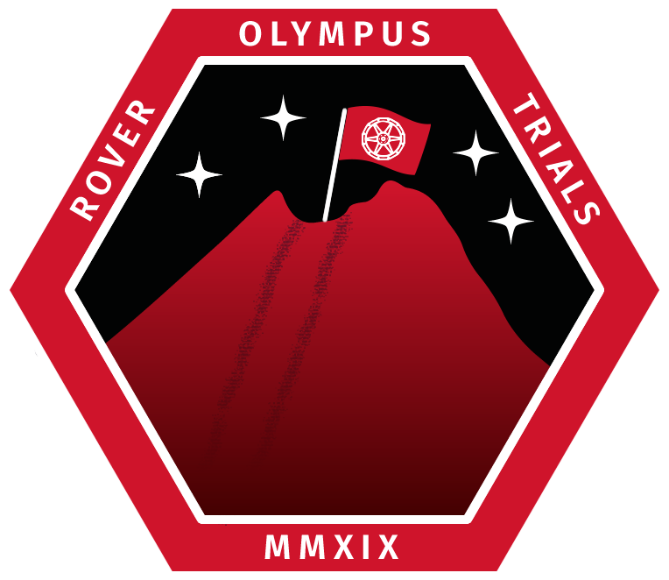

Introduction:
We are team Ares from Kingston university, our team consists of the project manager: Iras Charles, Secretary Erika Mcdowell, programmer Emily, design engineer Bertie Kemp, construction officer Nicolo and electrician Sam Vietch. Our project consists of a small rover with a simple claw mechanism at the bottom of the chassis, designed to capture a few core samples and return them semi-autonomously.

Mission Statement:
Our mission is to design a semi-autonomous rover capable of navigating a set of defined parameters over terrain and obtaining and returning sample containers.

Project Structure:
Name | Role | Year/Course | Contact Details
Iras Charles | Project Manager | 2019/Astronautics | K1819154@Kingston.ac.uk
Erika Mcdowell | Secretary | 2019/Astronautics | K1911976@Kingston.ac.uk
Emily Scothern | Programmer | 2019/Computer Science | K1940601@Kingston.ac.uk
Bertie | Design Engineer | 2019/Astronautics | K1910784@Kingston.ac.uk
Nicolo Fasciano | Construction Officer | 2019/Astronautics | K1942892@Kingston.ac.uk
Sam Vietch | Electrician | 2019/Astronautics | K1908741@Kingston.ac.uk

Preliminary Schedule:
In order to test that the movement of the rover works correctly, we will make sure that it can traverse an inclination of 30 degrees, can run over rocks of 5cm, and can still work even in loose material like sand. It should also be able to drive for 30 minutes minimum. We will test if it can rotate in place.
In order to test the crane system that we plan to use, we will place a sample container that we will 3D print ourselves and practice picking up the sample and putting it into the rover. We will try to pick the sample up in suboptimal conditions until we are confident that we will be able to pick the sample up in any condition possible on the competition day.
To test the electronics, microprocessor boards and wireless connection, we will test all wires and connections and make sure they are not going to short circuit or fail in any way. To test the microprocessor boards, we will check the code we are going to upload to them and test it thoroughly until we are sure there are no bugs and that the code is robust and wont fail. For the connection, we will test this by trying to introduce interference and poor signal, to refine our design and allow it to still maintain connection, even in very difficult conditions signal wise.
Development will occur in phases, with each phase tied to our funding rounds, aimed at completing a component of the rover. The first phase will occur from February through Mars and will be concerned with constructing the rover chassis and wheels, the second phase will occur from March to April and will revolve around the rover electronics and sample retrieval system, the final phase will run from April through May and will be concerned with in field testing.

Preliminary Budget:
We are planning to fund £250 ourselves, in order to get the grant from the match funding from KU backer. This gives us an overall budget of £500, however we doubt we will need this amount for the final rover, including prototypes and mistakes.

Mechanical Design:
The model for the body of our rover will be designed using the software SolidWorks because it’s easy to use and suitable for drawing mechanical parts. The model, once completed, must be saved as a .SLS file that can be read by a slicing software. A slicing software is an important part of the 3D printing process. It converts the .SLS file into a G-Code, which is a language a 3D printer can understand and use to produce the final object. Each type of 3D printer has a related G-Code and we must use the right slicing software for the printer chosen (GoPrint3D, 2019).

In order to stay within the weight limit (2 kg), we must use a light material, but we must also try to optimize the volumes of the chassis. The most suitable material for our purposes is PLA. It’s a very tough and stiff material and it’s also easy to print. Good alternatives would be ABS and ASA.

Requirements:
The requirements that our rover must fulfil are as follows:
Basic Requirements:
- Be able to drive 30m.
- Be always connected to the controller (laptop) .
- Be able to turn on the spot, have very precise movement.
- Be able to retrieve a sample.
- No visible damage during the vibration test.
Advanced Requirements:
- Be able to drive over steep gradients, loose terrain.
- Be able to collect every single sample and store them inside the rover for transport.
- Use machine learning to automate parts of the mission.
- Rover does not break in any way during the vibration test.

Basic Requirements:
- Have the battery last 30 minutes whilst being able to operate each part of the rover.
- Always have a connection to a laptop, no connection losses.
- All wiring and connections are solid, no electrical short circuits or issues.
- The motors for movement are powerful enough and have enough torque to not get stuck on any large rocks, or to spin in soft material.
Advanced Requirements:
- Use automated scripts to allow the rover to drive itself to the sample collection points.
- Use machine learning to allow the rover to recognise a sample container and then retrieve it automatically.

Risk Management:
The major risks of our design are:
The caterpillar tracks and whether they will perform well enough for our rover to move around well enough. We will manage this risk by making the system as robust as possible and making sure it does not break during the testing phase.
Another risk is the wireless connection from the microprocessor boards to our control centre (laptop). This is a risk because if the connection drops out, we will be unable to control the rover and lose time in the competition. To avoid this risk, we will place a large amount of focus on making the connection between our control and our rover and test it thoroughly.
There is also the risk of team members struggling with the tasks they have been assigned to do and struggling with their roles. We will avoid this by not staying solely in our roles, if one team member is struggling with something, we will all help to the best of our abilities. If there is a task where a different team members has more knowledge on, then they will help that team member to complete their task, so they can learn how to do it, instead of the other team member just coming in and doing it for them.
The goal is start with the simplest version possible that meets the requirements. Advanced requirements, such as automation will be added if time permits. This way even if time runs short, we have a working rover that can be used for the competition.
Any unexpected risks that we cannot foresee, we will work together as a team and look to experts in our university to overcome the issues.
To properly deal with risks we will follow our universities health and safety guidelines and will fill out the required paperwork, and lab pack, in coordination with university personnel, to ensure the highest safety standards are followed.

Trade Offs:
There are two main areas where trade-offs have to be made.
Movement:
There are several different ways a rover can move over the surface. The main ways are normal wheels, legs that ‘walk’, and caterpillar tracks.
Wheels have the advantage that they are the simplest, easiest to design and can have different grip levels. The disadvantages are that if a wheel is in the air, it will free spin, wasting energy and not moving the rover, there is also less contact area with the ground, so each wheel has a relatively high pressure on the ground.
Legs have the advantage of very high grip and not getting stuck in the air. They have the disadvantage of being much slower, more fragile and taking more stress.
Caterpillar Tracks have the advantage of spreading the weight more evenly over the surface as well as allowing the rover to climb over obstacles more easily. The disadvantages are that the tracks are much more difficult to make work and have a higher chance of breaking.

Sample Collection:
We came up with several ways to collect samples. These included a robotic arm, a scoop, and a crane system.
The robotic arm has the advantage of being very versatile and can move the sample to a variety of places, as well as being more precise. The disadvantage of the robotic arm is that it is extremely complicated and hard to engineer. It is also quite fragile, especially for the vibration test as it must have only one contact point.
The scoop has the advantage of being strong and resistant to the vibration test and can pick up potentially the greatest number of samples. The disadvantage of the scoop is that it will pick up lots of dirt as well as the sample and is not precise in any way.
The crane system has the advantage of being very precise when picking up the sample and being able to be contained inside the rover chassis. The disadvantage of the crane system is that it is very delicate and has lots of moving parts.

Selection:
For movement, we have decided to choose caterpillar tracks as they are the most versatile and offer the ability to turn on the spot better than the other options. If we can make sure they are robust and do not break, then it will be worth it. It is a riskier choice than the other options but if it works, it will be worth it.

There is the option to either buy tank kit and use the tracks of those or buy all the components separately. The advantage of using a kit is that it has everything we need including spare parts and everything is designed to work together, disadvantage is that they tend to be expensive and are not necessarily customizable. Buying the separate components lets us fully customize our drive kit, however it is time consuming and can lead to more errors and incompatibility.

For sample collection, we decided to use the crane system as we think it will have a better chance of surviving the vibration test as all the parts are inside the rover. We also chose the crane as it will be easier to construct than a robotic arm.
The crane will most likely be built out of separate parts, bought or 3D-printed and not a pre-built set up as it is an extremely unique scenario. Separate parts may be bought, such as a toy grappler to use for picking up the samples, however compatibility could be an issue. More research and tests will have to be done to determine the precise components.
Pre-made parts: Custom parts:
Chassis  Sheets of Plastic, Composite, Metal  - Cheap  - Quick  - Most likely still require shaping, cutting, epoxying or riveting | Fully 3D printed or 3D printed with Metal Frame  - Takes more time  - Fully customizable to what is needed
Drive system  Buy Tank Kit  - Has everything we need  - Only partially customizable  - More expensive??  - Easier | Build from components  - Time consuming  - Fully customizable
Claw/Grabbing Unit  Toy Grapple  - Cheap  - Quick  - Not compatible/hard to program? | Custom 3d printed/components  - Time consuming  - Customizable/Easier to program  - Precise?

Design Baseline:
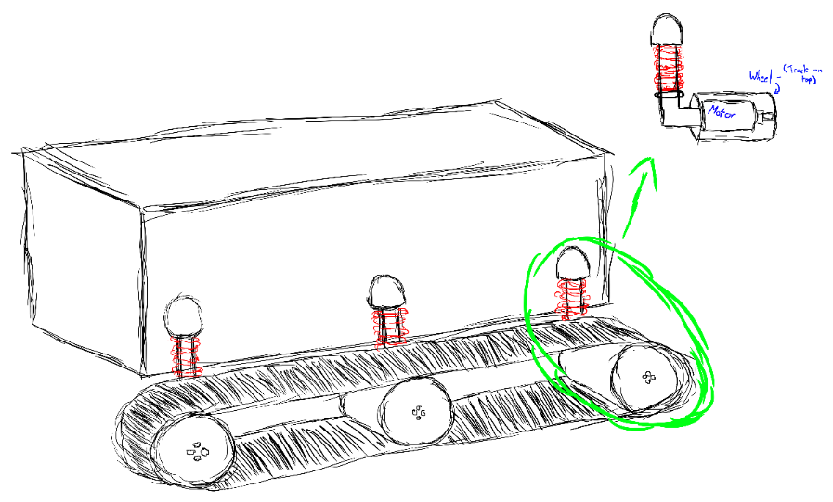

The picture above is how we plan on making the caterpillar track. We will attach two bearings at the end of each caterpillar track, with a motor attached to a wheel in the middle to drive the track. All three of these will be attached to the body with a metal beam hanging down, and a spring around the outside to act as a shock absorber and give our rover some suspension. This will allow our rover to overcome small obstacles and soft terrain, as well as being able to survive small drops.
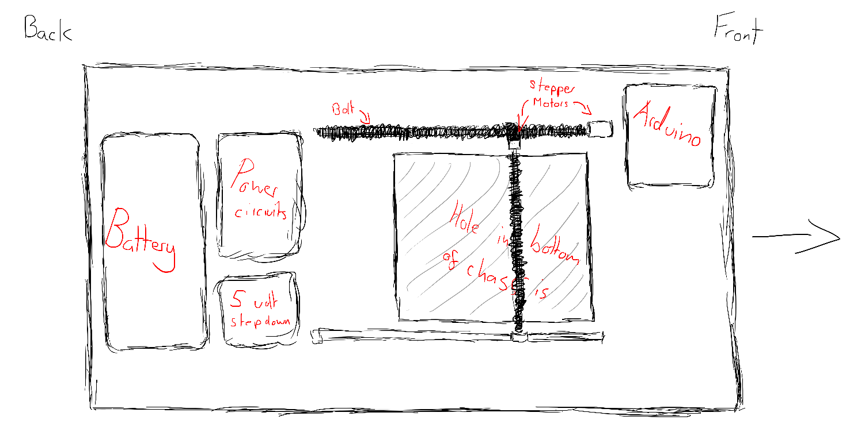
The drawing above shows how the electronics would sit inside the rover, including the crane assembly in the middle. The crane system basically works by having two stepper motors and two threaded bolts, in the same way some 3D printers move their extruders around. The battery and power conditioning circuitry will be seated at the back of the rover, whilst the Arduino and possibly a raspberry pi will be at the front.

References:
GoPrint3D (2019) What is slicing software, and what does it do?. [online] Available at:
https://www.goprint3d.co.uk/blog/what-is-slicing-software-and-what-does-it-do/ (Accessed: 18th Dec 2019).

Simplify3D (2019) Ultimate 3D printing materials guide. [online] Available at: https://www.simplify3d.com/support/materials-guide/ (Accessed: 18th Dec 2019).

